Sketching Linear Graphs Using the Gradient and the y-Intercept

Question | Reflect – what do you know? | Expect – what do you think the graph might look like? | Check – sketch the graph here.
$$y=x$$ |  |  | 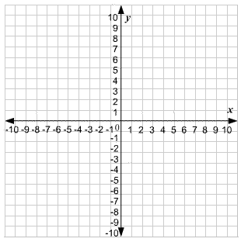
$$y=2x$$
$$y=3x$$
$$y=3x+1$$
$$y=3x+2$$
$$y=3x-2$$

Question | Reflect – what do you know? | Expect – what do you think the graph might look like? | Check – sketch the graph here.
$$y=2+3x$$
$$y=2-3x$$
$$y=-3x+2$$
$$y=2(-3x+2)$$
$$y=\frac{1}{2}(-3x+2)$$
$$y=\frac{1}{3}(-3x+2)$$

