Sketching Straight Line Graphs

Question – sketch the graph of… | Reflect – what do you already know? | Expect – what might it look like? Why? | Check – show your working here!
$$y=x$$ |  |  | 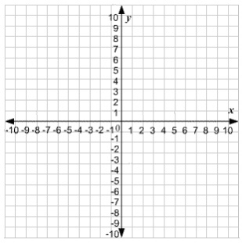
$$y=2x$$
$$y=3x$$
$$y=-3x$$

Question – sketch the graph of… | Reflect – what do you already know? | Expect – what might it look like? Why? | Check – show your working here!
$$y=-3x+1$$
$$y=-3x+2$$
$$y=3x+2$$
$$y=3x-2$$

Question – sketch the graph of… | Reflect – what do you already know? | Expect – what might it look like? Why? | Check – show your working here!
$$y=-2+3x$$
$$y=3-2x$$
$$y=3-x$$
$$y=-x+3$$

Question – sketch the graph of… | Reflect – what do you already know? | Expect – what might it look like? Why? | Check – show your working here!
$$y=-\frac{x}{2}+3$$
$$y=-\frac{1}{2}x+3$$
$$y=\frac{1}{2}x+3$$
$$y=\frac{x}{2}+3$$

