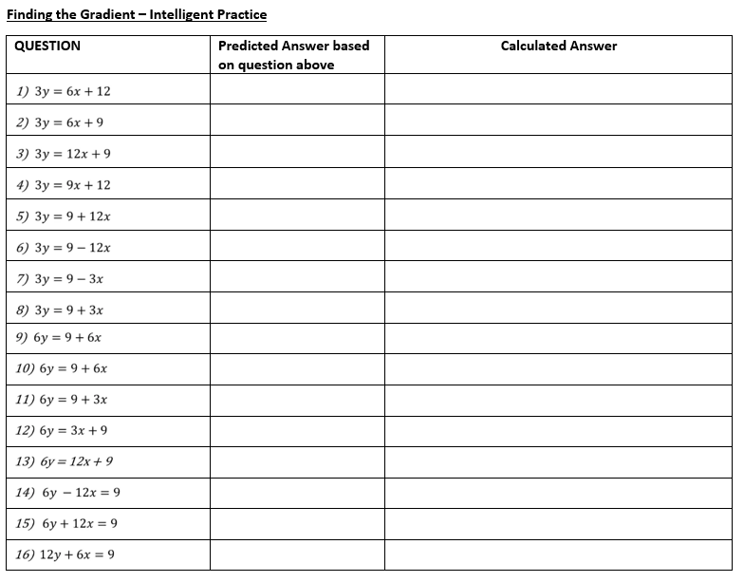

**Finding the Gradient – Intelligent Practice**

|  |  |  |
| --- | --- | --- |
| **Question** | **Predicted Answer based on question above** | **Calculated Answer** |
|  |  |  |
|  |  |  |
|  |  |  |
|  |  |  |
|  |  |  |
|  |  |  |
|  |  |  |
|  |  |  |
|  |  |  |
|  |  |  |
|  |  |  |
|  |  |  |
|  |  |  |
|  |  |  |
|  |  |  |
|  |  |  |